Global Risk Assessment for Pensions and
Other Nonbank Financial Institutions

Dan Waters
Managing Director
ICI Global

Friday
May 1, 2015

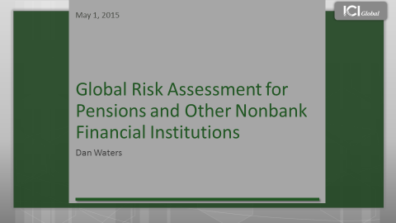
Good morning and thank you for inviting me to join you today.
Since the 2008 financial crisis, policymakers have enacted some of the most sweeping financial regulatory reforms in the past 70 years to help monitor and mitigate systemic risk.
Initially policymakers focused on the banking sector, but recently, they have broadened their focus to include insurance companies, asset managers, and their products, which could affect pension funds.
My remarks will focus on the debate surrounding asset management and systemic risk. This is important for the pension industry because of the key role that asset managers play in in providing well-diversified investment options in defined contribution arrangements.
By way of context for my remarks, let me give you a brief background on ICI Global. ICI Global is the international arm of the Investment Company Institute, or ICI, and together we serve a fund membership that includes regulated funds publicly offered to investors in jurisdictions worldwide, with combined assets of $19.6 trillion.
Thus, my remarks today will be coming from the perspective of mutual funds and similarly regulated funds in markets worldwide.
The debate surrounding asset management and systemic risk is extremely complex, so I will focus on four basic areas today:
- systemic risk and why banks are particularly susceptible to it;
- how asset management works and why neither funds nor their managers present the systemic risk that regulators are worried about;
- some of regulators’ main concerns about asset management;
- and how this could affect pension funds.
<<CLICK TO SLIDE>>
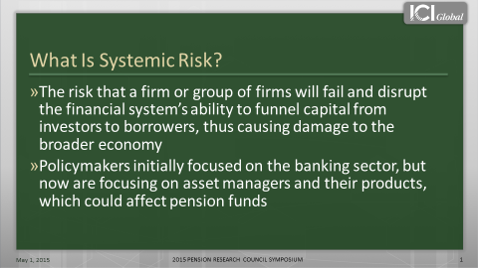
So what is systemic risk?
This question is hard to answer, because there is no single definition. Yet perhaps the most comprehensive explanation is that it is the risk that a firm or group of firms will fail and disrupt the financial system’s ability to funnel capital from investors to borrowers, thus causing damage to the broader economy.
This sort of catastrophic instability is what happened in 2008. In response, governments gave regulators broad authority to monitor systemic risk and a range of tools to address it.
One of those tools is the power to designate a financial entity as a systemically important financial institution, or SIFI.
A SIFI is an institution whose distress or disorderly failure could place at risk the stability of the financial system as a whole.
If designated, a SIFI is subjected to heightened regulation and oversight, which in the United States, includes “enhanced prudential supervision” by the Federal Reserve and bank-like capital requirements. In addition, the SIFI could be forced to pay into a resolution fund to help prop up a failing bank or other systemically important institution.
In the United States, the Financial Stability Oversight Council, or FSOC, has the power to designate an institution as a SIFI. On the global level, the Financial Stability Board, or FSB, is currently designing a methodology for designating nonbank financial intermediaries, which the FSOC could then apply to funds or their managers.
As part of their analysis, the FSOC and FSB have drawn heavily on their understanding of how banks contribute to systemic risk, referring to asset management activities as “shadow banking.”
Yet the term shadow banking is a misnomer, because asset management is fundamentally different from banking.
I will discuss these differences momentarily, but to understand them, we need to understand how banks work, why they are susceptible to collapse, and how they can contribute to systemic risk.
<<CLICK TO NEXT SLIDE>>
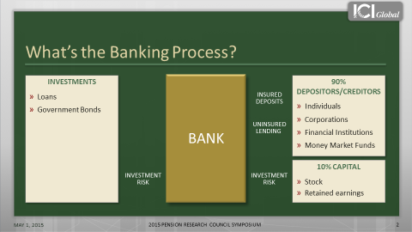
First consider who uses banks. On the right side we have depositors and creditors, such as individuals, corporations, and financial institutions. They loan money to the bank through various means. One of those means is through insured deposits, like savings accounts. Another way is through uninsured deposits, like large time deposits or other types of lending, such as repurchase agreements. Repurchase agreements, or repos, are uninsured but collateralised with securities such as government or agency bonds.
<<CLICK TWICE [two arrows, representing insured deposits and uninsured lending, go to the bank]>>
In this stylised example, 90 percent of this bank’s funding comes from deposits and other forms of debt instruments.
<<CLICK ONCE [one arrow goes from the bank to the investments] >>
The bank uses them to finance loans or buy bonds. It then receives interest on these assets and uses the proceeds to pay interest to the depositors or creditors.
Any profit the bank earns is a return on capital and accrues to its equity investors, as either retained earnings or dividends, as shown on the right. In this example, the bank’s capital accounts for 10 percent of its balance sheet.
These insured deposits and uninsured loans have a stated nominal value, meaning their value does not fluctuate, which creates a fixed set of liabilities on the bank. The bank’s investments or assets, however, do rise and fall in value.
Given that the value of banks’ assets can vary but their liabilities cannot, banks have to hold capital to absorb changes in asset values and to protect bank depositors and creditors from losses.
If a bank does not have enough capital to absorb a large drop in asset values, bank creditors and uninsured depositors could suffer losses.
<<CLICK ONCE [arrow goes from investments through bank to capital]>>
Thus, one of the key points is that banks take on all of the investment risk.
Another key point is that banks rely on high levels of deposits and other borrowings to finance their balance sheets, which magnifies the effects on a bank’s capital when asset prices change. This is also known as leverage, which is measured by the leverage ratio.
A leverage ratio of 10:1 means a 1 percent decline in the value of a bank’s assets will cause its capital to fall by 10 percent. Among the largest US banks, the average balance sheet leverage ratio is 9:1. Thus, banks are highly leveraged, which leaves them and their capital highly susceptible to changes in the value of their assets.
So what happens when a bank fails?
As we know, during times of financial market stress, asset prices can fall sharply. During these times, there is a risk that depositors and lenders might pullback their funding to the bank.
If asset prices fall and a bank’s borrowers or depositors pull back quickly, the bank may not be able to sell its assets fast enough — and at a high enough price — to cover its liabilities.
If a bank has to sell assets for less than it has valued them, those realised losses are absorbed by its capital, which erodes the buffer that protects the bank’s uninsured lenders and depositors.
Therefore, a downward spiral of selling assets at fire-sale prices ensues, forcing the bank to realise losses, which further erodes its capital and leads lenders to pullback even more before the bank becomes insolvent. This experience, often referred to as a run, can cause a bank to collapse quickly.
<<CLICK TO NEXT SLIDE>>
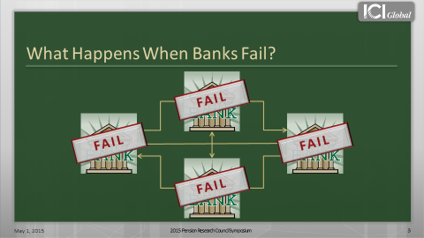
And because banks are highly interconnected and often loan to one another, if one bank fails, it can put other banks at jeopardy.
<<CLICK ONCE [banks shake and fail one-by-one]>>
Now let’s look at asset management, which is fundamentally different from banking. First let’s review the investors.
<<CLICK TO NEXT SLIDE>>
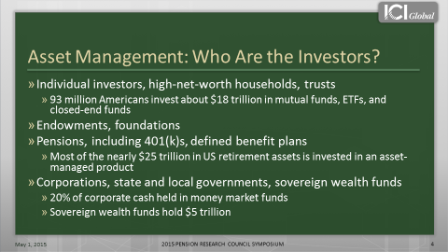
Investors fall into four categories, although they are not necessarily distinct.
One of the biggest groups is individual investors, such as retail investors or high-net-worth households.
By way of example, there are about 93 million Americans who invest in mutual funds, ETFs, and closed-end funds. They use these products to save for various financial goals, such as retirement, education, or a home.
In the United States, the total amount invested in these funds is about $18 trillion, while globally, the total amount is about $33 trillion.
The second group comprises endowments and foundations, and the third category is one this audience knows very well: pensions.
US retirement assets amount to nearly $25 trillion, and the asset management industry manages a large portion of private pensions and those of state and local governments. Asset managers also manage some of the US government employees’ Federal Thrift Savings Plan assets.
The final category is corporations, state and local governments, other types of large entities, and sovereign wealth funds.
<<CLICK TO NEXT SLIDE>>
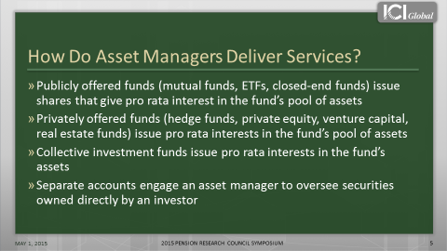
How do asset managers deliver their services?
The easiest way of thinking about it is that they have two basic means of doing so: through either pooled investment vehicles or separate accounts.
In the case of a pooled vehicle, such as a mutual fund or hedge fund, investors buy shares that are equal to their proportion of the overall fund. They also receive the returns and the losses of that fund on a pro-rata basis, and share in the overall costs on a pro-rata basis, such as trading costs.
Thus, fund investors do not directly own the securities. Whereas in the case of a separate account, investors own the securities directly, which is a key distinction that I will return to.
In terms of ownership, the manager does not own the fund or securities. Instead, the securities are owned by the fund or the investor in the separate account. In terms of holding, the securities are held in custody by a third party, usually in a custodial bank.
How does the asset management process work?
<<CLICK TO NEXT SLIDE>>
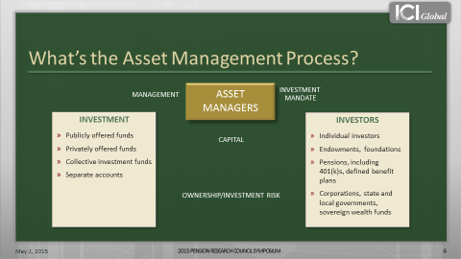
In this stylised example, the investors are on the right and they provide an investment mandate to the asset manager.
<<CLICK [arrow representing the investment mandate goes from investors to asset manager] >>
Now you might be saying, if I invest in a fund, I am not giving an investment mandate to the manager and telling the fund how to manage its product.
Well, actually you are.
By law, a fund has to offer a prospectus, which includes language about the investment objective that the fund manager is required to adhere to.
<<CLICK [arrow representing the management goes from asset managers to investment] >>
Thus, whether an investor is investing in a fund or separate account, the investment mandate is coming from the investor, which governs how the manager manages the products.
<<CLICK TWICE [arrow representing the capital goes from investors to investment, arrow representing investment risk goes toward investors] >>
This is the key point though: in a fund, the investors take on all the risk and reward. If a fund experiences gains or losses, the investors absorb those gains or losses, not the manager.
<<CLICK TO NEXT SLIDE>>
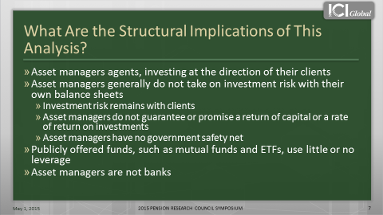
What are the key implications of our analysis?
First, fund managers act as agents. They invest on behalf of their clients and leave all the risk to the end investors. Whereas banks invest for their own accounts, as principals, and put their own capital at risk.
Second, unlike banks, asset managers generally do not take on investment risks on their own balance sheet and they do not guarantee or promise a rate of return.
Third, and this is a very important distinction: funds use little to no leverage, unlike banks which are highly levered. In fact, leverage is a core attribute of any bank. Whereas in a mutual fund, leverage is sharply limited by law, which reduces the leverage within the funds, and the potential amplification that a fund's flows may have on the market.
The US regulatory regime also imposes other requirements that help limit funds’ potential for systemic risk.
<<CLICK TO NEXT SLIDE>>
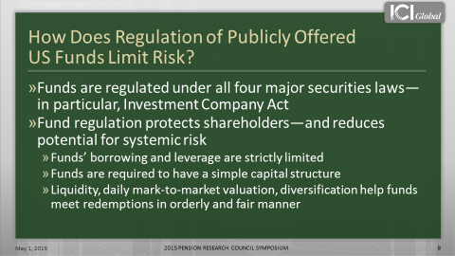
In the United States, funds must adhere to four major securities laws, and under those laws, mutual funds and ETFs must allow for daily purchases and redemptions of fund shares.
Consequently, the day-to-day management of a fund’s liquidity is a core competency for any mutual fund manager. To help manage that liquidity, funds hold marketable stocks, bonds, and other types of financial instruments. They also have to mark-to-market daily, using fair valuation techniques, and there are diversification and other requirements that may be in place for tax or other reasons.
All these regulations are designed to ensure that funds are managed in an orderly and fair manner.
Taken together, the structural characteristics and regulatory requirements that define asset management make two things abundantly clear.
- First, asset management is fundamentally different from banking.
- Second, because of their differences, funds and their managers have different risk profiles from banks, and thus do not present the systemic risk that regulators are worried about.
Yet despite this, some regulators continue to theorise how mutual funds could destabilise the financial system.
- One of those theories is that mutual fund investors “herd.”
- A second theory is that mutual funds create a “first mover advantage.”
Let’s discuss the first theory: that fund investors “herd.” Some regulators assert that in a market crises, fund investors could panic and exit funds en masse. Theoretically, this could force fund managers to liquidate fund assets in fire sales, which could lead to the collapse of asset values and potentially disrupt the broader financial system.
Given the long period of low interest rates and the anticipated rate increases, certain regulators are particularly concerned about this happening in bond funds. Yet historical and empirical evidence about how US bond fund investors behave refute this theory.
<<CLICK TO NEXT SLIDE>>
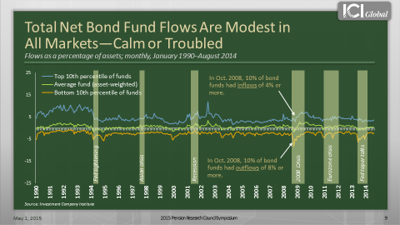
This chart shows a range of flows on a monthly basis as a percentage of assets.
The green line is the net impact in the industry, and this is for all US bond funds, going back to 1990.
As you can see, the net flows hover around zero. Thus, during any given month, net industry flows to bond funds are either slightly below or above zero in terms of flows as a percentage of assets.
Now, certainly individual funds can have large outflows, and this yellow line shows the 10th percentile funds in any given month.
For instance, in October 2008, 10 percent of bond funds had outflows of 8 percent or more. But at the same time, this blue line shows that 10 percent of bond funds had inflows of 4 percent or more. Thus, the net of those flows was about a negative 1.5 percent — and that was during the height of the financial crisis.
This means that fund investment is a relatively closed system; money coming out of one fund is often immediately reinvested in another fund.
This is because investors want to maintain their market exposure. They want to stay in the investment profile that they have set up. And they are usually doing this through a 401(k) or with the help of a financial advisor.
Thus, contrary to some regulators’ hypothesis, fund investors do not herd. One of the reasons is that these investors tend to be very stable. A large part of them are retail investors, like households, who are saving for long-term needs, such as retirement.
<<CLICK TO NEXT SLIDE>>
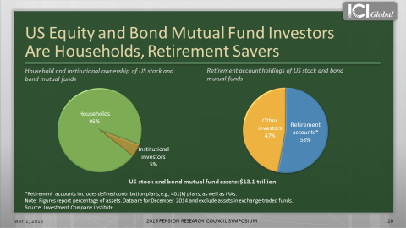
Indeed, 95 percent of the $13.1 trillion in US equity and bond mutual fund assets are held by households. Looked at another way, 53 percent is held in retirement accounts.
Now let’s turn to the second hypothesis: that the structure of a mutual fund creates a “first mover advantage.”
This goes back to our earlier discussion about the difference between a pooled investment vehicle and a separate account. In a separate account, investors directly own the securities, which means they absorb all the trading costs.
In a fund, however, investors own a portion of the fund, and they share the trading costs with other investors.
The first mover advantage theory says that because fund investors share trading costs, which cumulate as more investors leave a fund, investors have an incentive to be the “first mover” during times of financial stress, which could lead to runs.
For example, if an investor left a fund and the manager had to sell securities to accommodate the redemption, both the investor leaving the fund and the investors staying in the fund would bear the trading costs. If more investors left, the remaining investors would have to bear more and more trading costs.
Thus, the remaining investors would be paying higher trading costs than those paid by the “first movers.” Certain regulators are concerned that in times of financial stress, this theoretical “advantage” could provide an incentive for investors to leave the fund “first,” which could lead to a run.
US fund managers, however, are able to manage these costs so as not to disadvantage their remaining shareholders.
<<CLICK TO NEXT SLIDE>>
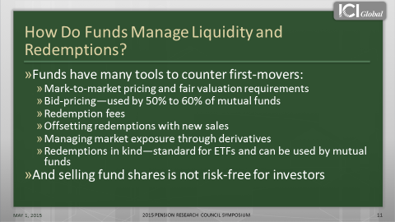
First, as discussed, fund managers are required to mark-to-market their funds’ portfolios on a daily basis, using forward pricing and fair valuation methods to avoid predictable price movements.
Fund managers are required to either use the price that they could sell the security for, known as the bid price, or use the price that is at the mid-point between the bid and ask price.
Using a bid- or mid-price passes some of the trading costs along to the investor leaving the fund because this pricing method values the shares near to what the fund would receive if it needed to sell assets to accommodate the redemption.
Another way that funds manage costs is by imposing redemption fees on investors who leave a fund within a certain window of time after they invest in it.
In addition, most funds also reserve the right to redeem shares in kind if investors with especially large trades want to quickly redeem their shares, so that rather than receiving cash the investors are paid with a slice of securities.
This last one is particularly relevant for pension products, because mutual funds or collective investment funds often have the option to redeem in-kind if the retirement plan sponsor has not given sufficient warning that it is removing the plan from the fund.
So what does all this mean for pension funds?
Regulators are in the early stages of understanding sources of systemic risk and its transmission outside the banking sector. Yet global bodies, such as the FSB, have moved much closer to designating asset managers and their funds, possibly including large pension funds, as global SIFIs.
The implications for plan participants and the regulatory consequences outside the United States are uncertain.
In the United States, however, the implications are much clearer and most certainly could cause a small group of funds and their investors, including pension plan participants, to bear significant costs upon designation or in the event of a future collapse of another SIFI.
For example, the FSB released a consultation, which proposed several thresholds for identifying asset managers and investment funds as SIFIs.
Under one scenario, any asset manager with more than $1 trillion of assets under management worldwide or any individual fund with more than $100 billion in assets would be considered for designation.
If these thresholds were applied to the US regulated fund industry, and the funds and managers meeting the thresholds were designated as SIFIs, a staggering share of the assets managed by funds and included in DC retirement plans could be swept under Federal Reserve oversight. Which means they would be subjected to capital requirements and resolution fund costs.
Of the $18.1 trillion that investors have in US regulated funds, more than $9.7 trillion could come under the Fed’s supervision. Of the $6.3 trillion in DC plans more than $3.4 trillion could come under such supervision, with all the added costs and potential controls over investing that such oversight would bring.
Thus, the debate surrounding asset management and systemic risk has very real implications for the pension industry, and I hope my remarks have provided some insight into the issues at stake.
Thank you.
###

