Understanding the Debate Surrounding Asset Management and Systemic Risk and How it Could Affect the Brazilian Market

Dan Waters
Managing Director
ICI Global

Wednesday
20 May 2015

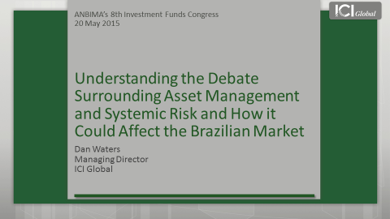
Good afternoon and thank you for inviting me to join you today.
Over the past 20 years, Brazil’s fund industry has grown to become one of the largest in the world, with total regulated fund assets of $990 billion US dollars.
This is in no small part thanks to ANBIMA, which supports funds and advocates on their behalf, for the benefit of investors here and worldwide.
This is an important mission, and one that ICI Global shares.
For those of you who are not familiar with us, ICI Global is the international arm of the Investment Company Institute, or ICI, and together we serve a fund membership that includes regulated funds publicly offered to investors in jurisdictions worldwide, with combined assets of $19.4 trillion.
Thus, my remarks today will be coming from the perspective of regulated funds, and mainly US and EU funds, as they hold the bulk of regulated fund assets worldwide, and data for these funds are more comprehensive than those available for most other regions.
Funds today are in unchartered territory. The industry is enjoying tremendous success, with almost $33 trillion in global fund assets. Yet with this growth has come heighted regulatory scrutiny.
Specifically, efforts are underway at both the global and national level to assess whether funds and their managers present systemic risk.
Thus far, these efforts have mainly affected EU and US funds. Yet the debate surrounding funds and financial stability is not a regional debate. It is a global debate, with very real implications for funds and their investors worldwide, especially here in Brazil.
Before we discuss how this debate could affect Brazil, however, we need to understand the players and issues at stake.
Specifically, we need to understand:
- exactly what policymakers mean when they talk about “systemic risk” — and why banks in particular have been historically susceptible to it;
- how asset management works;
- why neither funds nor their managers present the systemic risk that regulators are worried about; and
- some of regulators’ main concerns about asset management.
<<CLICK TO SLIDE>>
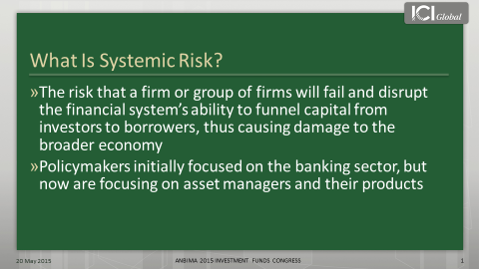
So what is systemic risk?
This question is hard to answer, because there is no single definition. Yet perhaps the most comprehensive explanation is that it is the risk that a firm or group of firms will fail and disrupt the financial system’s ability to funnel capital from investors to borrowers, thus causing damage to the broader economy.
In 2008, we saw exactly this sort of catastrophic instability. In response, governments gave regulators broad authority to monitor systemic risk and a range of tools to address it.
One of those tools is the power to designate a financial entity as a systemically important financial institution, or SIFI.
A SIFI is an institution whose distress or disorderly failure could place at risk the stability of the financial system as a whole.
If designated, a SIFI is subjected to heightened regulation and oversight. For example, in the United States, this would include “enhanced prudential supervision” by the Federal Reserve and bank-like capital requirements. In addition, the SIFI could be forced to pay into a resolution fund to help prop up a failing bank or other systemically important institution.
In the United States, the Financial Stability Oversight Council, or FSOC, has the power to designate an institution as a SIFI, and it is currently analysing whether US funds or their activities pose a systemic risk.
On the global level, the Financial Stability Board, or FSB, is designing a methodology for designating nonbank financial intermediaries, which national regulators would apply to funds or their managers.
As part of their analysis, the FSOC and FSB have drawn heavily on their understanding of how banks contribute to systemic risk, referring to asset management activities as “shadow banking.”
Yet the term shadow banking is a misnomer, because asset management is fundamentally different from banking.
I will discuss these differences momentarily, but to understand them, we need to understand how banks work, why they have been historically susceptible to collapse, and how they can contribute to systemic risk.
<<CLICK TO NEXT SLIDE>>
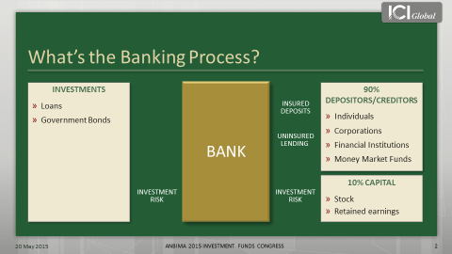
I recognize that discussing how banks work may seem a bit basic, but having a firm understanding is critical to understanding some of the issues at stake.
In this stylised example of a US bank, we have our depositors and creditors who loan money to the bank through various means, such as insured deposits or other types of uninsured lending.
<<CLICK TWICE [two arrows, representing insured deposits and uninsured lending, go to the bank]>>
As we can see, 90 percent of this bank’s funding comes from these types of deposits and debt instruments, which the bank uses to finance loans or buy bonds.
<<CLICK ONCE [one arrow goes from the bank to the investments] >>
The bank of course receives interest on these assets and uses the proceeds to pay interest to the depositors or creditors.
These insured deposits and uninsured loans have a stated nominal value. Thus, their value does not fluctuate, which creates a fixed set of liabilities on the bank. The bank’s investments or assets, however, do fluctuate in value.
Given that the value of banks’ assets can vary but their liabilities cannot, banks have to hold capital to absorb changes in asset values and to protect bank depositors and creditors from losses.
If a bank does not have enough capital to absorb a large drop in asset values, bank creditors and uninsured depositors could suffer losses.
<<CLICK ONCE [arrow goes from investments through bank to capital]>>
Thus, one of the key points is that a bank takes on all of the investment risk.
Another key point is that banks rely heavily on deposits and other borrowings to finance their balance sheets, which magnifies the effects on a bank’s capital when asset prices change. This is also known as leverage, which is measured by the leverage ratio.
Among the largest US banks, the average balance sheet leverage ratio is 9:1. This means a 1 percent decline in the value of a bank’s assets will cause its capital to fall by 9 percent. Thus, banks are highly leveraged, which leaves them and their capital highly susceptible to changes in the value of their assets.
As we know, during times of financial market stress, asset prices can fall sharply. During these times, there also is a risk that depositors and lenders might pull back their funding to the bank.
If asset prices fall and a bank’s borrowers or depositors pull back quickly, the bank may not be able to sell its assets fast enough and at a high enough price to cover its liabilities.
If a bank has to sell assets for less than it has valued them, those realised losses are absorbed by its capital, which erodes the buffer that protects the bank’s uninsured lenders and depositors.
Therefore, a downward spiral of selling assets at fire-sale prices ensues, forcing the bank to realise losses, which further erodes its capital and leads depositors and lenders to pull back even more before the bank becomes insolvent. This experience, often referred to as a run, can cause a bank to collapse quickly, and can lead to other bank failures as well.
Now let’s look at asset management, which is fundamentally different from banking. Once again, I know this is basic for this audience. Yet I think it is important to review the asset management process because it will serve to highlight the fundamental differences between banking and asset management — differences that lie at the heart of the systemic risk debate.
<<CLICK TO NEXT SLIDE>>
Investors fall into four categories. I am not going to go through all of these, but one of the biggest groups, is individual investors, such as retail investors or high-net-worth households. Another notable category is pensions.
To put the size of these two groups into context, let me give you a little data. In the United States, about 93 million people have invested nearly $18 trillion in mutual fund assets, ETFs, and closed-end funds. These are mainly long-term investors who use these products to save for various financial goals, such as a home, education, or retirement.
Which brings us the size of our second category. US retirement assets amount to nearly $25 trillion, with about 30 percent of that total invested in mutual funds through defined contributions plans and individual retirement accounts.
<<CLICK TO NEXT SLIDE>>
Asset managers deliver their services through two basic means: either pooled investment vehicles or separate accounts.
The key distinction between these two is that in a pooled investment vehicle, such as a mutual fund or hedge fund, the investors do not directly own the securities. Whereas in the case of a separate account, investors own the securities directly.
In terms of ownership, the manager does not own the fund or securities. Instead, the securities are owned by the fund or the investor in the separate account. In terms of holding, the securities are held in custody by a third party, usually in a custodial bank.
<<CLICK TO NEXT SLIDE, AND THEN CLICK ONCE>>
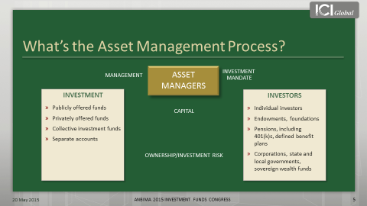
In this stylised example of a US mutual fund, the investors provide an investment mandate to the asset manager, which governs how the manager manages the products.
<<CLICK THREE TIMES [arrow representing the management goes from asset managers to investment; arrow representing the capital goes from investors to investment, arrow representing investment risk goes toward investors] >>
This is the key point though: in a fund, the investors take on all the risk and reward. If a fund experiences gains or losses, the investors absorb those gains or losses, not the manager.
<<CLICK TO NEXT SLIDE>>
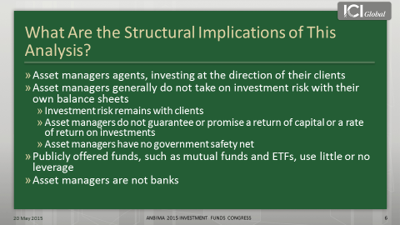
What are the key implications of our analysis?
First, fund managers act as agents. They invest on behalf of their clients and leave all the risk to the end investors. Whereas banks invest for their own accounts, as principals, and put their own capital at risk.
Second, unlike banks, asset managers generally do not take on investment risks on their own balance sheet and they do not guarantee or promise a rate of return.
Third, and this is a very important distinction: funds use little to no leverage, unlike banks which are highly levered. In fact, leverage is a core attribute of any bank. Whereas in a regulated fund, leverage is sharply limited by law, which reduces the leverage within the funds, and the potential amplification that a fund's flows may have on the market.
In the United States, the regulatory regime also imposes other requirements that help limit funds’ potential for systemic risk.
<<CLICK TO NEXT SLIDE>>
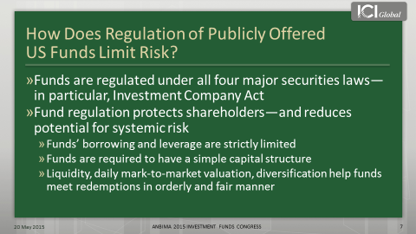
US funds must adhere to four major securities laws, and under those laws, mutual funds and ETFs must allow for daily purchases and redemptions of fund shares.
Consequently, the day-to-day management of a fund’s liquidity is a core competency for any mutual fund manager. To help manage that liquidity, funds hold marketable stocks, bonds, and other types of financial instruments. They also have to mark-to-market daily, using fair valuation techniques, and there are diversification and other requirements that may be in place for tax or other reasons.
All these regulations are designed to ensure that funds are managed in an orderly and fair manner.
Taken together, the structural characteristics and regulatory requirements that define asset management make two points abundantly clear.
- First, asset management is fundamentally different from banking.
- Second, because of their differences, funds and their managers have different risk profiles from banks, and thus do not present the systemic risk that regulators are worried about.
Yet despite this, some regulators continue to theorise how mutual funds could destabilise the financial system.
- One of those theories is that mutual fund investors “herd.”
- A second theory is that mutual funds create a “first mover advantage.”
Let’s discuss the first theory: that fund investors “herd.” Some regulators assert that in a market crises, fund investors could panic and exit funds en masse. Theoretically, this could force fund managers to liquidate fund assets in fire sales, which could lead to the collapse of asset values and potentially disrupt the broader financial system.
Given the long period of low interest rates and the anticipated rate increases, certain regulators are particularly concerned about this happening in bond funds.
Yet historical and empirical evidence about how US bond fund investors behave refute this theory.
<<CLICK TO NEXT SLIDE>>
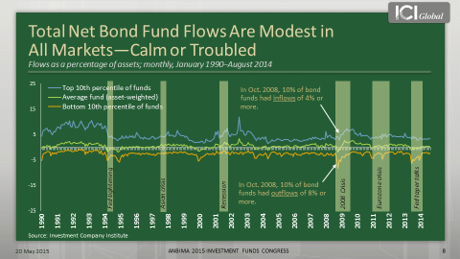
This chart shows a range of flows on a monthly basis as a percentage of assets.
The green line is the net impact in the industry, and this is for all US bond funds, going back to 1990.
As you can see, the net flows hover around zero. Thus, during any given month, net industry flows to bond funds are either slightly below or above zero in terms of flows as a percentage of assets.
Now, certainly individual funds can have large outflows, and this yellow line shows the 10th percentile funds in any given month.
For instance, in October 2008, 10 percent of bond funds had outflows of 8 percent or more. But at the same time, this blue line shows that 10 percent of bond funds had inflows of 4 percent or more. Thus, the net of those flows was about a negative 1.5 percent — and that was during the height of the financial crisis.
This means that fund investment is a relatively closed system; money coming out of one fund is often immediately reinvested in another fund.
This is because investors want to maintain their market exposure. They want to stay in the investment profile that they have set up. And they are usually doing this through a defined contribution plan, such as a 401(k), or with the help of a financial advisor.
Thus, contrary to some regulators’ hypothesis, fund investors do not herd. One of the reasons is that these investors tend to be very stable. A large part of them are retail investors, like households, who are saving for long-term needs, such as retirement.
<<CLICK TO NEXT SLIDE>>
Ninety-five percent of the $13.1 trillion in US equity and bond mutual fund assets are held by households. Or looked at another way, 53 percent is held in retirement accounts.
Now let’s turn to regulators’ second hypothesis: that the structure of a mutual fund creates a “first mover advantage.”
The first mover advantage theory says that because fund investors share trading costs, which cumulate as more investors leave a fund, investors have an incentive to be the “first mover” during times of financial stress, which could lead to runs.
For example, if an investor left a fund and the manager had to sell securities to accommodate the redemption, both the investor leaving the fund and the investors staying in the fund would bear the trading costs. If more investors left, the remaining investors would have to bear more and more trading costs.
Thus, the remaining investors would be paying higher trading costs than those paid by the “first movers.” Certain regulators are concerned that in times of financial stress, this theoretical “advantage” could provide an incentive for investors to leave the fund “first,” which could lead to a run.
US fund managers, however, are able to manage these costs so as not to disadvantage their remaining shareholders.
<<CLICK TO NEXT SLIDE>>
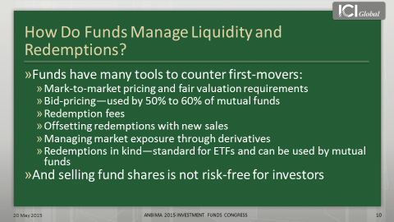
First, as discussed, fund managers are required to mark-to-market their funds’ portfolios on a daily basis, using forward pricing and fair valuation methods to avoid predictable price movements.
Fund managers are required to either use the price that they could sell the security for, known as the bid price, or use the price that is at the mid-point between the bid and ask price.
Using a bid- or mid-price passes some of the trading costs along to the investor leaving the fund because this pricing method values the shares near to what the fund would receive if it needed to sell assets to accommodate the redemption.
Another way that funds manage costs is by imposing redemption fees on investors who leave a fund within a certain window of time after they invest in it.
In addition, most funds also reserve the right to redeem shares in kind if investors with especially large trades want to quickly redeem their shares, so that rather than receiving cash the investors are paid with a slice of securities.
Thus, when one analyses regulators’ theory and looks at the evidence, two conclusions stand out:
- a mutual fund’s structure does not create a “first mover advantage,” and
- funds have many tools in place to manage liquidity and redemptions.
Of course liquidity — especially in the bond market — has been of great concern to regulators lately.
Indeed, the IMF recently released a report, arguing that regulated funds domiciled in developed countries may amplify shocks to emerging markets, such as Brazil, thus destabilising their markets.
It implies that this risk is growing because regulated funds and their investors have been piling into high-yield and emerging market debt.
The IMF theorises that when interest rates rise, bond fund investors may all try and sell their shares at once, creating a liquidity crunch that could ultimately disrupt the financial system of an emerging market country.
So as an emerging market, should Brazil be worried about regulated funds as source of systemic risk?
In short, no.
<<CLICK TO NEXT SLIDE>>
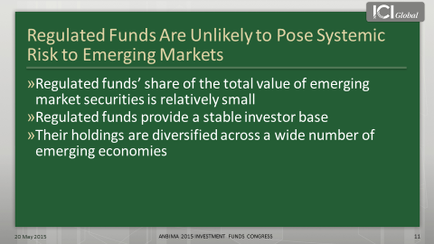
While over the past decade, regulated funds have contributed to the broad trend of portfolio capital flows to emerging countries, they are unlikely to pose systemic risk to emerging markets for three main reasons:
- regulated funds’ share of the total value of emerging market securities is relatively small;
- regulated funds provide a stable investor base; and
- regulated fund holdings are diversified across a wide number of emerging economies.
Let’s explore this first point by looking at the size of EU and US regulated fund holdings of emerging market bonds.
<<CLICK TO NEXT SLIDE>>
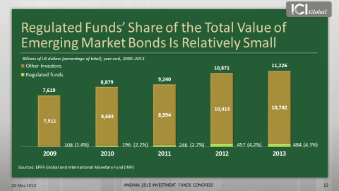
According to ICI Global research, EU and US regulated fund holdings of emerging market bonds grew from $109 billion in 2009 to $484 billion in 2013 — a staggering jump of nearly 350 percent.
At the same time, however, emerging market debt grew too, rising from $7.6 trillion in 2009 to $11.2 trillion in 2013.
Which means that in 2013, regulated funds held just 4.3 percent of total emerging debt outstanding. The rest — nearly 96 percent — was held by domestic investors and other foreign investors, such as hedge funds, sovereign wealth funds, or pension funds.
Let’s take a look at how this manifests itself in the Brazilian bond market.
<<CLICK TO NEXT SLIDE>>
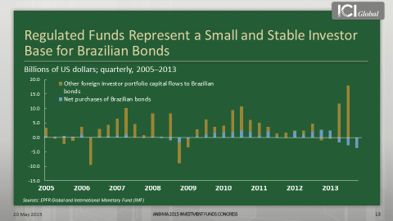
In this figure, the blue represents regulated funds net purchases of Brazilian bonds, while the brown represents all other foreign investor flows to Brazilian bonds.
Two things are striking about this slide:
- First, regulated funds’ net purchases of Brazilian bonds are small compared to flows from other foreign investors, which reinforces my previous point.
- Second, regulated fund flows are much more stable than flows from other foreign investors. It is not that regulated funds do not have inflows and outflows, but you simply do not see the kind of volatility in regulated fund flows that you see with foreign investor flows.
Thus, regulated funds represent a small and stable investor base for Brazilian bonds.
In fact, according to ICI Global research, US and European regulated funds hold more in Brazilian equities than they do in Brazilian bonds. For example, at the end of 2014, regulated funds held $92 billion in Brazilian equities, compared to just $40 billion in Brazilian bonds.
Now let’s contrast that to Brazil’s domestic fund investors and their holdings of Brazilian bonds and equities.
As of 2014, Brazil’s regulated fund industry had nearly $1 trillion in assets.
Of that $1 trillion, more than half — $570 billion to be exact — was invested in bond funds. While only $70 billion was invested in equity funds.
Thus, if global interest rates rise, the response of Brazilian bond fund investors is likely to be more important for Brazil’s financial stability than the response of EU or US bond fund investors.
To date, global regulators have not focused on the response of Brazilian fund investors, but who is to say they will not in the future? Especially given the size of Brazilian bond funds in aggregate.
<<CLICK TO NEXT SLIDE>>
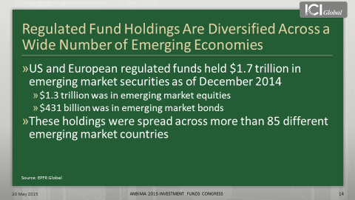
The third reason why regulated funds are unlikely to pose systemic risk to emerging markets is that their holdings are not concentrated in one or two specific countries, such as Brazil and China.
Instead, they are diversified across a wide number of emerging economies.
For example, as of December 2014, US and European regulated funds held $1.7 trillion in emerging market securities. Of that, only $431 billion was in bonds, while the vast majority, $1.3 trillion, was in equities. More to the point, however, these holdings were spread across more than 85 different countries.
Thus, taken all together, the evidence strongly suggests that regulated funds and their investors are unlikely to pose the kind of systemic risk to emerging markets that some regulators are concerned about.
Despite the arguments and data that I have presented today, the debate surrounding asset management and systemic risk continues and intensifies.
Global bodies, such as the FSB, have moved much closer to designating asset managers and their funds, as global SIFIs.
Thus far the FSB’s proposed methodology for identifying and designating funds or their managers as global SIFIs may only capture EU or US funds.
But given regulators’ increasing — yet unfounded — concerns about systemic risk and asset management, it is not out of the realm of possibility that funds and their managers in other countries, including here in Brazil, could be designated.
As mentioned earlier, designation would likely result in national regulators imposing capital requirements that have never been applied to funds and that do not fit the business model of funds.
It also would mean a regime of “enhanced prudential supervision” that would ultimately penalise investors, distort the fund marketplace, and compromise regulated funds’ important role in helping develop and strengthen capital markets.
Like many government officials around the world, such as in Europe and Japan, Brazilian authorities have recognised the need for — and the benefits of — deep, liquid capital markets. And Brazil is making progress in bolstering and growing its capital markets.
Among their many advantages, robust capital markets foster greater economic efficiency, stability, and flexibility.
But those advantages rest in the fact that funds and other capital market participants are not banks, and are not regulated like banks.
Undermining that financial diversity by imposing bank-style regulation on capital market participants will hinder the further development and growth of Brazil’s capital markets and will not serve the country’s economy well.
Thus, the debate surrounding asset management and systemic risk has very real implications for Brazil, and I hope my remarks have provided some insight into the issues at stake.
Thank you for your time and attention.
###

