Regulation by Conjecture:
Central Bankers’ Push to Regulate Capital Markets

2015 DUFAS Investment Management Forum
Wednesday
10 June 2015

Dan Waters
Managing Director
ICI Global

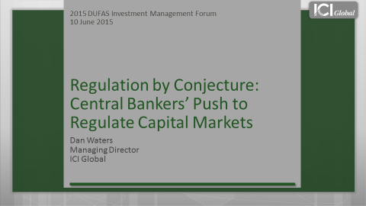
Good afternoon and thank you for inviting me to join you today.
I am honoured to have the opportunity to speak with you about an important debate that affects us all: the role of asset management in financial stability.
It seems fitting that this dialogue is taking place in The Hague, given that for more than one hundred years, international disputes have been heard and settled here.
Granted, the debate surrounding systemic risk and asset management is not characterised by the political and social conflict that attends many of the issues that are discussed and resolved here.
Yet it has become a crucial debate on a global scale, the outcome of which could fundamentally change the fund industry, and have serious repercussions for funds, their investors, and capital markets here and around the world.
At the heart of the debate is one central question: do funds or their managers threaten the stability of financial systems, nationally or globally? Currently, there are efforts underway at both those levels to address this question.
Thus far, these efforts have mainly threatened to affect large US funds, but it is possible that they could eventually affect the Dutch fund industry.
As of December 2014, the Netherlands had total regulated fund assets of $76 billion US dollars.
This is in no small part thanks to DUFAS, which supports funds and advocates on their behalf, for the benefit of investors here and worldwide.
Advancing the importance of fund investing is an important mission, and one that ICI Global shares.
For those of you who are not familiar with us, ICI Global is the international arm of the Investment Company Institute, or ICI. Together we serve a fund membership that includes regulated funds publicly offered to investors in jurisdictions worldwide, with combined assets of $19.4 trillion.
Thus, my remarks today will be coming from the perspective of regulated funds, and mainly US and EU funds, as they hold the bulk of regulated fund assets worldwide, and data for these funds are more comprehensive than those available for most other regions.
The debate surrounding asset management and systemic risk has many facets, but the most pressing issue for global funds and their managers is the work of the Financial Stability Board, or FSB — specifically its work on designing a methodology for identifying and designating global systemically important financial institutions, or G-SIFIs.
What is a SIFI? It is an institution whose distress or disorderly failure could place at risk the stability of the financial system as a whole. It is, in short, an institution that may occasion “systemic risk”—and thus must be subjected to heightened regulation and oversight.
But what is “systemic risk”? Given all the attention that policymakers have focused on stopping it, you might expect the term to be well understood. In fact, it is not. A report from a bipartisan think tank in Washington, DC offered not one definition, but 10 — each different from the other in some significant way.
Here is a definition that did not make that list: one economist says that systemic risk seems to be a “grab bag of scenarios,” however improbable they may be, “that are supposed to rationalise” more and more intervention by banking regulators in capital markets.
No matter what the definition, ICI and ICI Global are vigorously opposing this notion that regulated funds or managers should be subject to SIFI designation.
Before I get into the details of our case, let me make two overarching points.
First, this is not a debate about “regulation” versus “no regulation.” The fund sector around the world has thrived under sound regulation that addresses risks to investors and the capital markets. In particular, ICI and ICI Global have supported efforts to address abuses and close regulatory gaps exposed by the global financial crisis.
This is instead a debate over where and how risks to the financial system at large may occur — and what the most effective tools are to address such risks, out of the many tools that regulators have at hand.
My second point is that the stakes in this debate are high — for our investors, for our funds, and for our economies.
Designation of regulated funds could raise costs for investors, distort the marketplace for funds, and damage one of the best mechanisms for saving for retirement, financing business development, and stimulating economic growth.
ICI and ICI Global have worked hard to assemble a large, growing body of hard data and analysis, and to educate the FSB and policymakers around the world, about the structure and experience of regulated funds, why they should not be designated as SIFIs, and the harmful effects of designation on investors and the economy.
Unfortunately, the FSB continues to ignore the extensive record of empirical and historical evidence placed before it, as demonstrated by its recent, second consultation on its proposed methodology for identifying G-SIFIs.
The FSB released its first consultation on the matter in January 2014, proposing a methodology for assessing investment funds based on a materiality threshold of US$100 billion in assets. If applied, this threshold would have identified only 14 regulated US funds for further evaluation as potential G-SIFIs.
In a comment letter and meetings with the FSB, ICI and ICI Global explained why size alone reveals very little about whether a fund could pose risk to the financial system, and why any initial threshold used for evaluating investment funds should include balance-sheet leverage, which is what fuels serial contagion or systemic risk.
ICI and ICI Global also demonstrated that the existing regulation and defining characteristics of regulated US stock and bond funds, as well as their historical experience, make G-SIFI designation for these funds unnecessary and inappropriate.
<<CLICK TO NEXT SLIDE>>
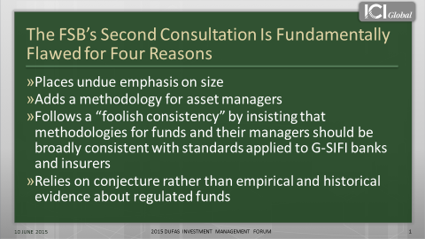
The FSB’s second consultation, however, takes none of this into account, and is fundamentally flawed for four reasons:
- first, it continues to place undue emphasis on size;
- second, it adds a methodology for asset managers;
- third, it follows a “foolish consistency” by insisting that methodologies for funds and the managers should be broadly consistent with standards applied to G-SIFI banks and insurers; and
- finally, it relies on conjecture rather than empirical and historical evidence about regulated funds.
First let’s discuss the FSB’s misguided focus on size.
The FSB proposes two possible materiality thresholds for investment funds that once again would single out large, highly regulated, transparent, and unleveraged funds for designation.
When applied, the materiality thresholds would result in 14 US funds as of March 31st.
These funds, however, have not been — and are not expected to be — sources of risk to global financial stability.
In fact, these funds demonstrated a remarkable degree of stability during the financial crisis. This is partly because they make little to no use of leverage and do not have the riskiness of banks, as they are among the most comprehensively regulated and highly transparent parts of the global financial system.
Thus, the FSB’s reliance on size as a primary driver of systemic risk is misguided, and moreover, arbitrary.
If size is truly a concern, it is inappropriate for the FSB to exclude from consideration other, larger investment pools such as pension funds and sovereign wealth funds.
Indeed, nine sovereign wealth and pension funds are larger than the world’s largest regulated fund. And another 26 sovereign wealth and pension funds exceed $100 billion in assets, one of FSB’s size-based evaluation thresholds.
Now let me be clear, ICI and ICI Global do not advocate designating these investment pools as G-SIFIs.
I am quite cognizant of the size and robustness of the Netherlands’ defined benefit pension system and we are not saying that the FSB should be striving to designate pension funds as systemic threats.
I am only pointing out the FSB’s exclusion of such funds because it highlights the confusing and nonsensical nature of the FSB’s proposed criteria for designation.
In another confusing move, the FSB’s second consultation adds a methodology for asset managers, which also places undue emphasis on size.
The consultation proposes a materiality threshold for asset managers, possibly based entirely on the amount of assets under management. This would have the effect of sweeping large asset managers into the designation net, almost all of which would be solely based in the United States.
The inclusion of asset managers is another fundamental flaw of the second consultation, because it conflicts with the FSB’s initial consultation, and the FSB’s rational for including asset managers is based on theoretical concerns rather than empirical evidence.
The FSB’s decision to include asset managers can only be described as a giant step backwards, because it departs from the FSB’s reasoned decision in the initial consultation to focus on individual investment funds.
Moreover, the FSB actually admits in its second consultation that adding an asset manager methodology conflicts with the comment record, including comments submitted by ICI and ICI Global.
Despite this acknowledgement, however, the FSB proposes a methodology for asset managers, based on concerns that an asset manager facing “distress or forced failure” could “potentially cause or amplify significant disruption to the global financial system.”
Yet there is no rationale for this concern. In fact, ICI and ICI Global have compiled and analysed an extensive amount of data on the matter, and we do not know of any instances of this occurring in the case of managers of regulated funds.
The third fundamental flaw in the second consultation is that the FSB is following a “foolish consistency” in designing its methodology.
Now what do I mean by “foolish consistency?”
The FSB continues to insist that methodologies for funds and their managers should be broadly consistent with standards applied to G-SIFI banks and insurers.
Yet aligning standards and remedies for regulated funds and their managers with those in banking is a “foolish consistency” because it discounts the fundamental differences between asset management and banking.
Asset managers are not banks. First, fund managers act as agents. They invest on behalf of their clients and leave all the risk to the end investors. Whereas banks invest for their own accounts as principals and put their own capital at risk.
Second, unlike banks, asset managers generally do not take on investment risks on their own balance sheet and they do not guarantee or promise a rate of return.
Third, funds use little to no leverage, unlike banks which are highly levered. In fact, leverage is a core attribute of any bank. Whereas in a US mutual fund, leverage is sharply limited by law, which reduces the leverage within the funds, and the potential amplification that a fund's flows may have on the market.
Given these fundamental differences, it is illogical for the FSB to apply bank-like standards to asset managers and their funds.
It also results in an unproductive process in which policymakers are focused on designating individual funds or firms, which are not sources of systemic risk.
<<CLICK TO NEXT SLIDE>>
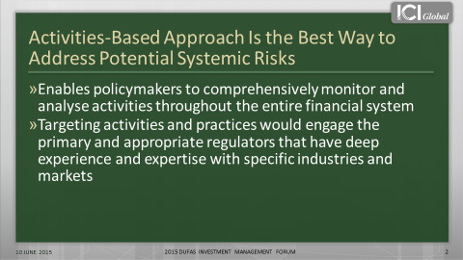
If there are systemic risks within the financial system, then policymakers should address them through a market-wide, activities-based approach, which serves two purposes.
- First, this approach would enable policymakers to comprehensively monitor and analyse activities throughout the entire financial system, giving them a higher likelihood of finding legitimate sources of systemic risk before they threaten to damage the economy.
- Second, targeting activities and practices would engage the primary and appropriate regulators that have deep experience and expertise with specific industries and markets.
ICI and ICI Global have vigorously engaged with the FSB and policymakers worldwide about the need for a market-wide, activities base.
Unfortunately, the FSB continues with its entity-based approach, which brings us to our final reason why the FSB’s consultation is fundamentally flawed.
Despite the fact that ICI and ICI Global have provided the FSB with an extensive and comprehensive body of evidence, showing why funds do not present the kind of systemic risk that regulators are worried about, the FSB insists on ignoring that data, relying on conjecture instead.
One of the FSB’s theories is that mutual fund investors “herd.”
The FSB asserts that in a market crisis, fund investors could panic and exit funds en masse. Theoretically, this could force fund managers to liquidate fund assets in fire sales, which could lead to the collapse of asset values and potentially disrupt the broader financial system.
Given the long period of low interest rates and the anticipated rate increases, regulators are particularly concerned about this happening in bond funds. Yet as you are about to see, historical and empirical evidence about how US bond fund investors behave refute this theory.
<<CLICK TO NEXT SLIDE>>
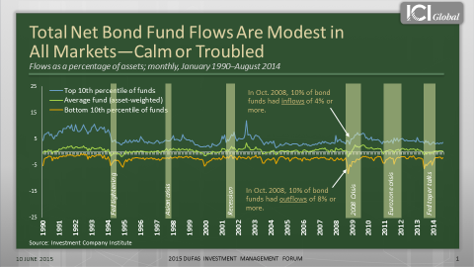
This chart shows a range of flows on a monthly basis as a percentage of assets.
The green line is the net impact in the industry, and this is for all US bond funds, going back to 1990.
As you can see, the net flows hover around zero. Thus, during any given month, net industry flows to bond funds are either slightly below or above zero in terms of flows as a percentage of assets.
Now, certainly individual funds can have large outflows, and this yellow line shows the 10th percentile funds in any given month.
For instance, in October 2008, 10 percent of bond funds had outflows of 8 percent or more. But at the same time, this blue line shows that 10 percent of bond funds had inflows of 4 percent or more. Thus, the net of those flows was about a negative 1.5 percent — and that was during the height of the financial crisis.
This means that fund investment is a relatively closed system; money coming out of one fund is often immediately reinvested in another fund.
This is because investors want to maintain their market exposure. They want to stay in the investment profile that they have set up. And they are usually doing this through a retirement account, such as a 401(k) in the United States, or with the help of a financial advisor.
Thus, contrary to the FSB’s hypothesis, fund investors do not herd. One of the reasons is that these investors tend to be very stable. A large part of them are retail investors, like households, who are saving for long-term needs, such as retirement.
<<CLICK TO NEXT SLIDE>>
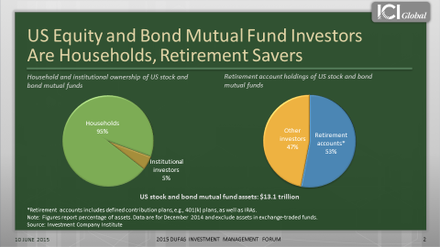
For example, in the United States, 95 percent of the $13.1 trillion in US equity and bond mutual fund assets are held by households. Or looked at another way, 53 percent is held in retirement accounts.
Another theory that the FSB and other policymakers are focused on is that the structure of a mutual fund creates a “first mover advantage.”
As we all know, fund investors own a portion of the fund, which among other things, means that they share trading costs with other investors.
The first mover advantage theory says that because fund investors share trading costs, which cumulate as more investors leave a fund, investors have an incentive to be the “first mover” during times of financial stress, which could lead to runs.
For example, if an investor left a fund and the manager had to sell securities to accommodate the redemption, both the investor leaving the fund and the investors staying in the fund would bear the trading costs. If more investors left, the remaining investors would have to bear more and more trading costs.
Thus, the remaining investors would be paying higher trading costs than those paid by the “first movers.” The FSB is concerned that in times of financial stress, this theoretical “advantage” could provide an incentive for investors to leave the fund “first,” which could lead to a run.
US fund managers, however, are able to manage these costs so as not to disadvantage their remaining shareholders.
<<CLICK TO NEXT SLIDE>>
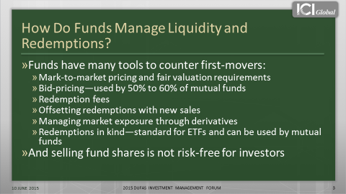
First, fund managers are required to mark-to-market their funds’ portfolios on a daily basis, using forward pricing and fair valuation methods to avoid predictable price movements.
Fund managers are required to either use the price that they could sell the security for, known as the bid price, or use the price that is at the mid-point between the bid and ask price.
Using a bid- or mid-price passes some of the trading costs along to the investor leaving the fund because this pricing method values the shares near to what the fund would receive if it needed to sell assets to accommodate the redemption.
Another way that funds manage costs is by imposing redemption fees on investors who leave a fund within a certain window of time after they invest in it.
In addition, most funds also reserve the right to redeem shares in kind if investors with especially large trades want to quickly redeem their shares, so that rather than receiving cash the investors are paid with a slice of securities.
This ability to manage liquidity and redemption costs speaks to the four main reasons why US regulated funds do not pose threat to financial security.
- First, the structure and comprehensive regulation of mutual funds and their managers not only protect investors, but limit systemic risks and the transmission of risk. Most notably, each regulated fund is a separate legal entity, meaning that the losses of one regulated fund are not absorbed by other funds or the fund manager.
- Second, as we saw earlier, investors do not “herd,” because regulated fund investors tend to be long-term, stable investors.
- Third, regulated funds do not “fail” like banks do, but instead routinely exit the business in an orderly fashion through mergers and liquidations. A liquidation follows an established, orderly process for distributing remaining assets to the fund’s investors and winding up the fund. In addition, regulated funds are highly substitutable. Thus, when a fund exits the business, it simply does not occasion disorder in the markets or otherwise “transmit distress” to other market participants.
- Finally, regulated funds are subject to regulatory limits on leverage and typically make little to no use of it.
As I said at the beginning of my remarks, the FSB’s proposed methodology for identifying and designating funds or their managers as G-SIFIs has mainly threatened to affect large US funds thus far.
But given regulators’ increasing — yet unfounded — concerns about systemic risk and asset management, it is not out of the realm of possibility that funds or their managers in other countries, including here in the Netherlands, could be designated.
Designation would likely result in national regulators imposing capital requirements that have never been applied to funds and that do not fit the business model of funds.
It also would mean a regime of “enhanced prudential supervision” that would ultimately penalise investors, distort the fund marketplace, and compromise regulated funds’ important role in helping develop and strengthen capital markets.
Here in Europe, that could seriously jeopardise the development and success of perhaps one of the most important initiatives for Europe’s economy: the Capital Markets Union, or CMU.
The goal of the CMU is to “further develop and integrate capital markets,” to “help reduce [Europe’s] very high dependence on bank funding,” and to “increase the attractiveness of Europe as a place to invest.”
Of course one of the keys to achieving this goal is increasing the use of other funding vehicles, such as investment funds.
Yet if policymakers impose highly prescriptive regulations on funds and their managers, they will not only run a significant risk of hindering the crucial role that funds play in developing and sustaining robust capital markets, but also diminishing the diversification in financial services that capital markets provide. Their actions could exacerbate volatility in markets, increase the probability of shocks to the financial system — and make those shocks more harmful, not less.
I am not saying that our funds, or capital market participants generally, are opposed to regulation. Sound regulation is crucial to the development and operation of robust capital markets.
Indeed as I mentioned earlier, US regulated funds in particular have prospered under a comprehensive and effective framework of regulation that has withstood the test of time.
But the advantages that capital markets bring — in promoting efficiency, economic stability, and economic flexibility — rest in the fact that funds and other capital market participants are not banks, and are not regulated like banks. Undermining that financial diversity by imposing bank-style regulation on capital market participants will not serve Europe’s economy well, and in fact could hamper its future success.
That is why it is so vital for us to pay close attention to these issues, and to make sure that policymakers get them right.
Thank you for your time and attention.
###

